Following are some of the important points to note during SVN check-ins.

**New SVN Comment Format**

The SVN Comments should be added in the new format mentioned below while committing the change in current stream and also while merging it in any other required stream.

This will be in Key-Value pair format.

Each key value pair is ‘~’ separated and each key is separated by ‘|’ character as below.

**Format**

CR**~<**CRNO>**|**

CRDESC**~<**CR DESC>**|**

ISSUE**~**<ISSUENO>**|**

ISSUESUB**~**<ISSUESUB>**|**

COMMENTS**~**<COMMENTS (IF ANY)>**|**

MERGED**~**<MERGING COMMENTS>

|  |  |
| --- | --- |
| **KEY** | **VALUE** |
| CR | Provide the CR number as in jira |
| CRDESC | Provide the CR description as in jira |
| ISSUE | Provide Ticket number or jira reference as on support log/jira |
| ISSUESUB | Provide Ticket subject or jira subject as on support log/jira |
| COMMENTS | Provide any additional comments if you want to. For general check-ins you can put the details in this section since there will be no CR or Issue no linked to it. Eg Optimization changes etc |
| MERGED | Additional merging information like from which stream it has been merged.  E.g. NA (For non-merging change)  Stream details (For merging done from other stream) |

**Note:**  SVN will support only the above Key codes and they need to be added in the same defined sequence too. Altering any of the key codes above or its sequence would popup an error from SVN while checking in your changes as shown below. The below validation popup is displayed because the key “CR” was altered to “CR..”

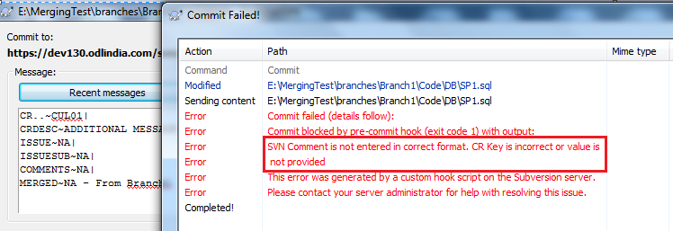

**NO Manual Merging**

This point is a very important. From now on all merging should strictly be done only using Tortoise SVN merging tool process only. Manual Merging should not be done unless it is approved by your manager.

**Some Examples of SVN Comment Format**

|  |  |
| --- | --- |
| **Comments in Development/Sub/Support stream** | **Comments during Merging in other streams E.G. TRUNK** |
| **//For CR Commits – Mention CR Details** | |
| CR~CUL01|  CRDESC~ADDITIONAL MESSAGE TAGS|  ISSUE~NA|  ISSUESUB~NA|  COMMENTS~<COMMENTS IF REQUIRED>|  MERGED~NA | CR~CUL01|  CRDESC~ADDITIONAL MESSAGE TAGS|  ISSUE~NA|  ISSUESUB~NA|  COMMENTS~<COMMENTS IF REQUIRED>|  MERGED~ From CUL 326.09 Stream |
| **//For UAT ISSUE FIXES – Mention both CR details and Issue details** | |
| CR~CUL01|  CRDESC~ADDITIONAL MESSAGE TAGS|  ISSUE~60010|  ISSUESUB~TOTAL BOOKING VALUE IS INCORRECT|  COMMENTS~NA|  MERGED~NA | CR~CUL01|  CRDESC~ADDITIONAL MESSAGE TAGS|  ISSUE~60010|  ISSUESUB~TOTAL BOOKING VALUE IS INCORRECT|  COMMENTS~NA|  MERGED~ From CUL 326.09 Stream |
| **//For Support Issue Fixes (Not related to a CR or after CR has been merged into TRUNK) – Mention Issue Details** | |
| CR~NA|  CRDESC~NA|  ISSUE~60020|  ISSUESUB~CANT BOOK END POINT SERVICE|  COMMENTS~NA|  MERGED~NA | CR~NA|  CRDESC~NA|  ISSUE~60020|  ISSUESUB~CANT BOOK END POINT SERVICE|  COMMENTS~NA|  MERGED~ From CUL 326.09 Stream |
| **//For General Check-in’s not linked to CR or Issue.** | |
| CR~NA|  CRDESC~NA|  ISSUE~NA|  ISSUESUB~NA|  COMMENTS~OPTIMZED SERVICE SEARCH LOGIC IN SP|  MERGED~NA | CR~NA|  CRDESC~NA|  ISSUE~NA|  ISSUESUB~NA|  COMMENTS~OPTIMZED SERVICE SEARCH LOGIC IN SP|  MERGED~NA – From CUL 326.09 Stream |

**Merging Compare Reporting Utility**

We have a utility tool which can give you a report in excel format displaying details about all the revisions in your current working stream. Additionally it also provides useful information about which of these revisions are not merged in the Merging Stream.

**Note:** This utility need MS Excel installed on your machine. So it won’t work on machine not having MS Excel.

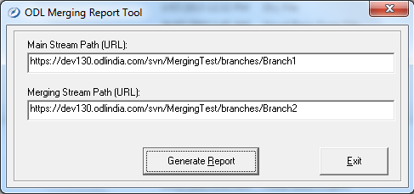

ODL Merging Report Tool Utility

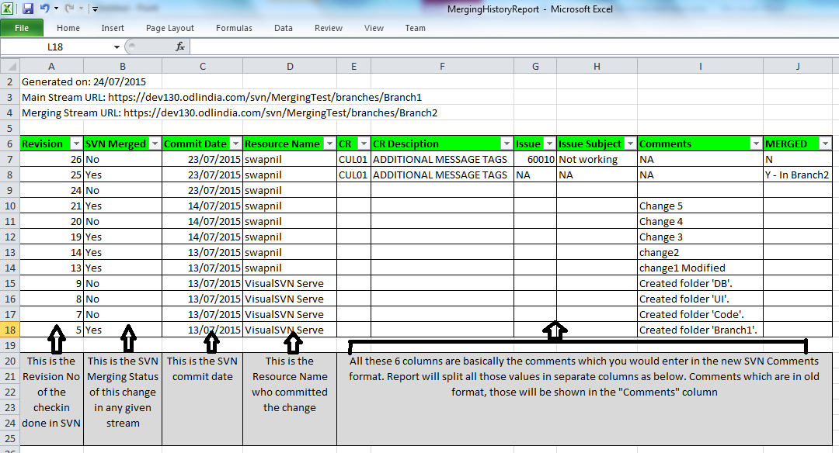

Report output in Excel format